Scope

This document is to assist in getting ILO configured on the server and then configured for monitoring correctly in INC.

Initial INC Configuration
Verify the ILO templates are loaded to perform the monitoring
- Log into INC
- Log into the client
- Expand Configuration
- Expand Monitoring
- Click on Service Templates
- Verify the template HP Servers is listed
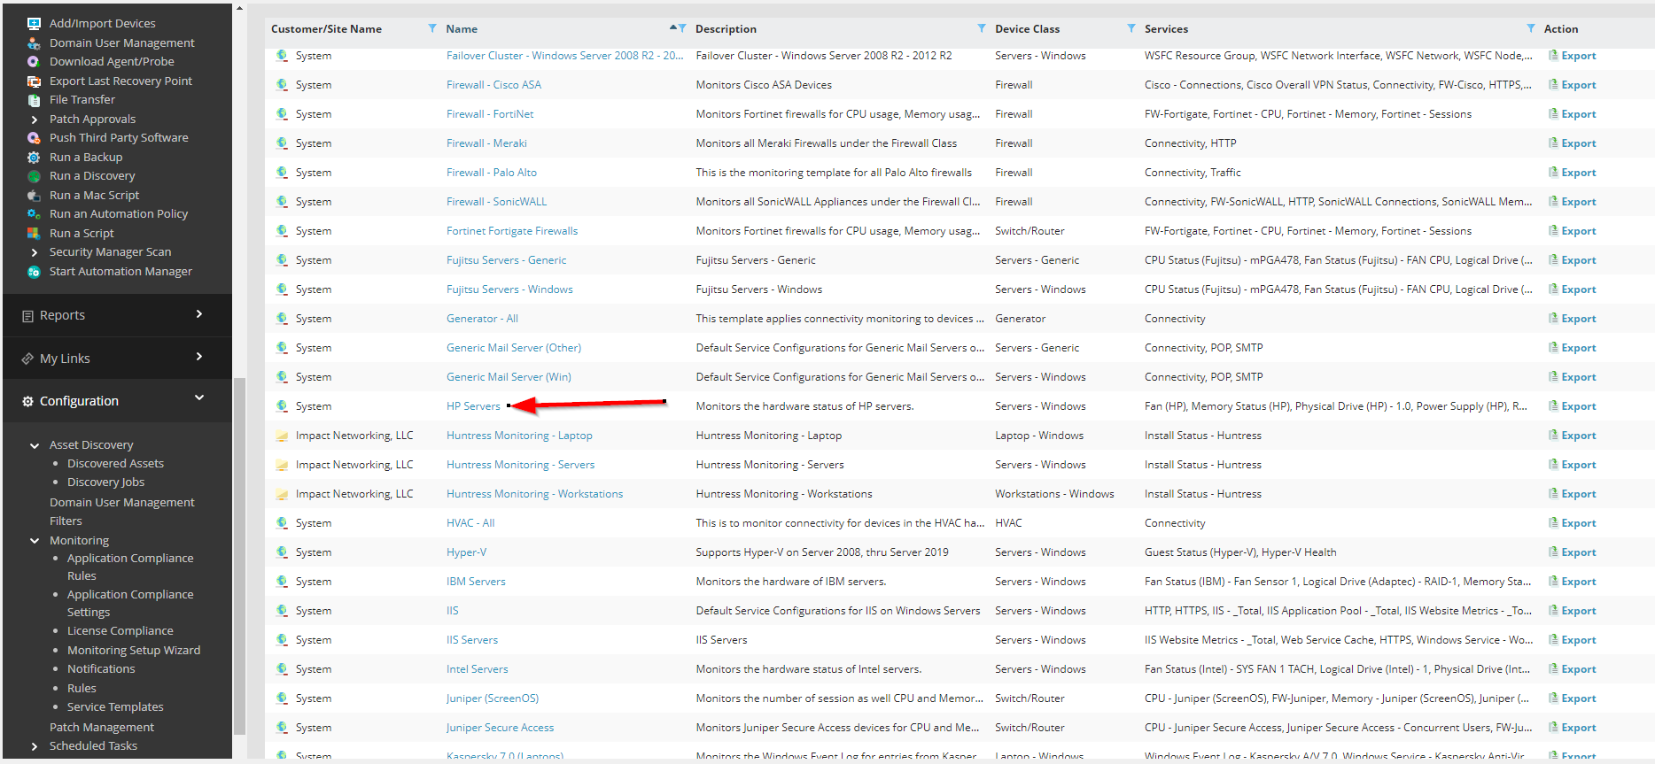
HP Server Configuration
- Log into ILO for the server
- Select Security in the left hand menu
- Under the Access Settings menu item click the pencil next to Server
- Enter a Server name
- 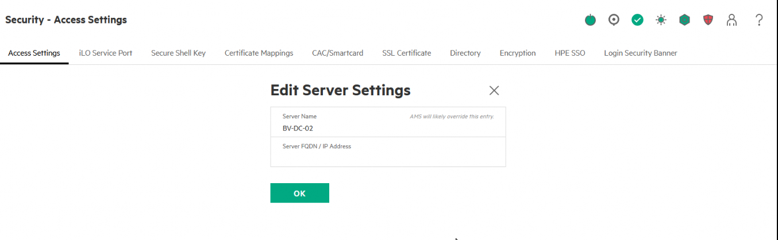
- Click OK
- Click the Pencil next to Account Service
- Enable Password Complexity
- Set Password length to 16
- 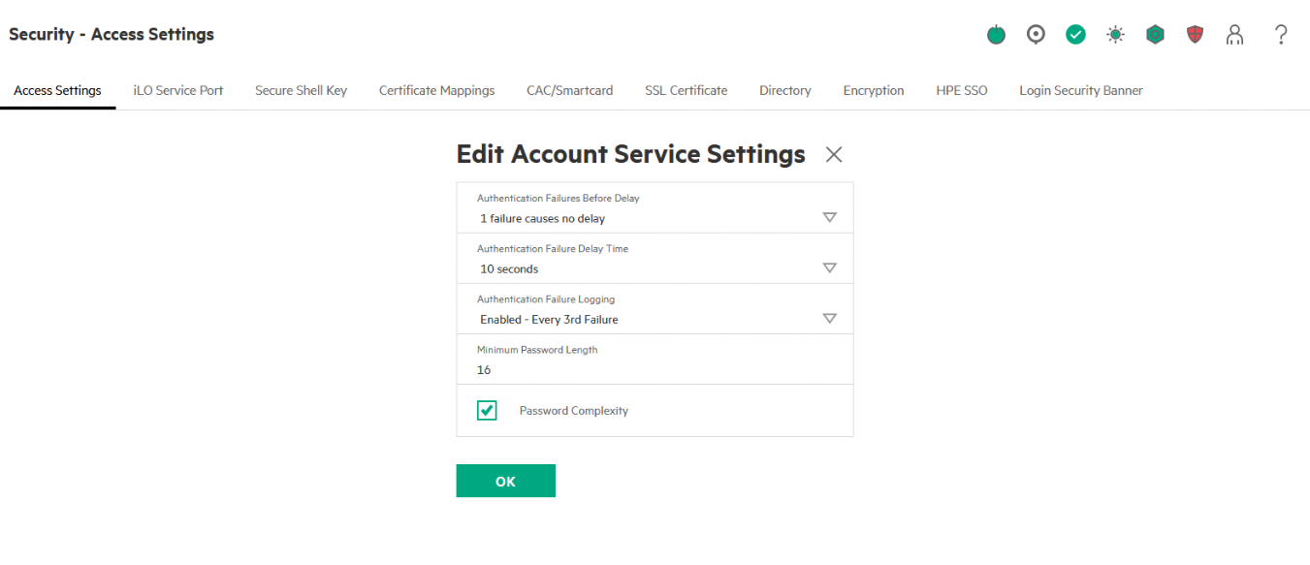
- Click OK
- Select Administration
- Click User Administration
- Scroll to the bottom and click New
- Ensure Configure User is selected and click Next
- Click Enable User
- For Login Name enter Impact
- For User Name enter Impact
- For the passwords enter a complex password
- Under User Privileges click “select all”
- Click Add user
- 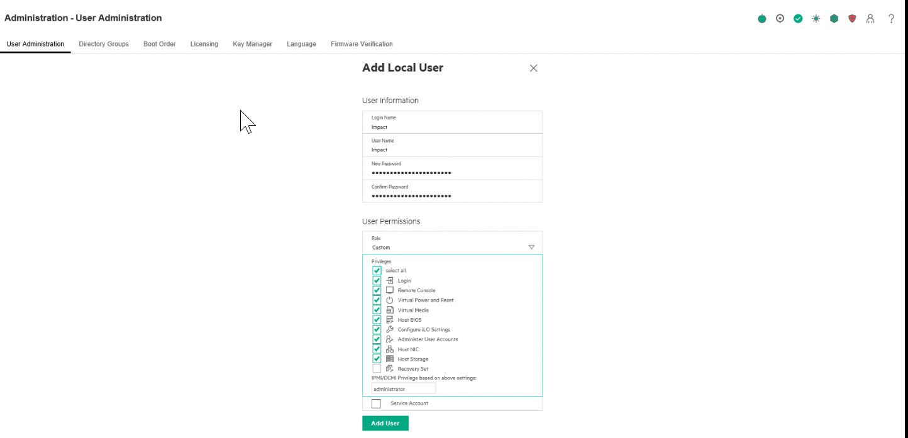
- Log out
- Log in using the Impact account
- Select Administration
- Click User Administration
- Click the checkbox for the Administrator user
- Scroll down and click Edit
- Click Change Password
- Enter a complex password
- Scroll down and click Update User
- 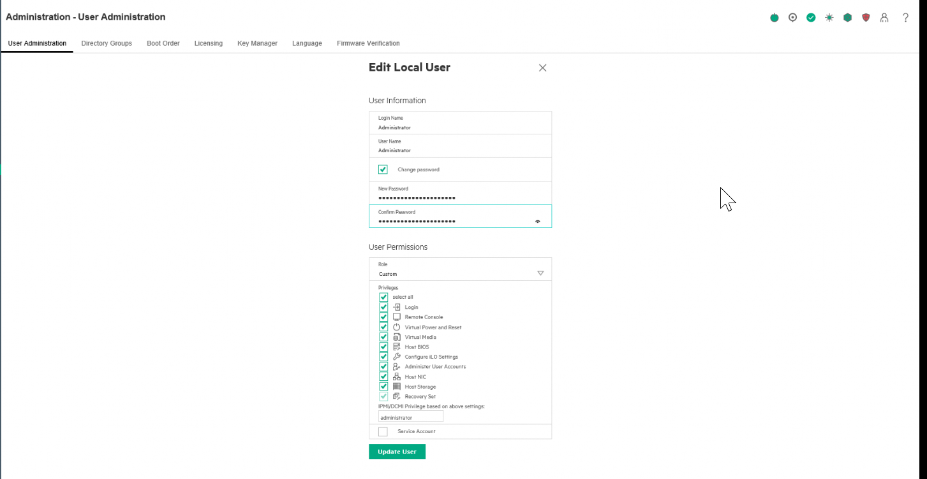
- ***Enter both passwords into IT GLUE
- Click Management in the left hand side menu
- Enter a system location (I.e. Corp Office - Rack 2)
- Under Read Community 1 enter impact
- Scroll down and click Apply (right under the SNMP Port box)
- 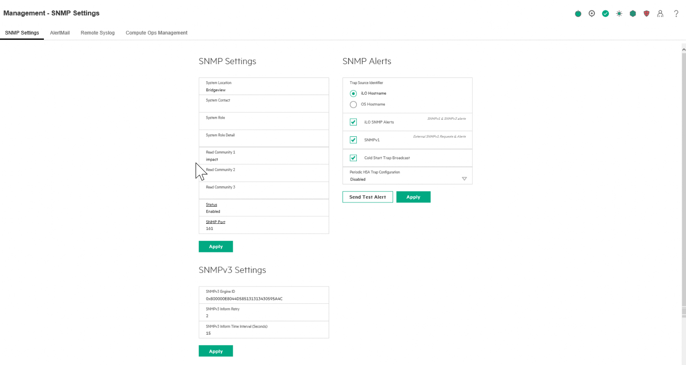
- Logout of ILO

Enable monitoring in INC
- Log into INC
- Log into the client
- Expand Configuration
- Expand Asset Discovery
- Click on Discovery Jobs
- Click Add
- 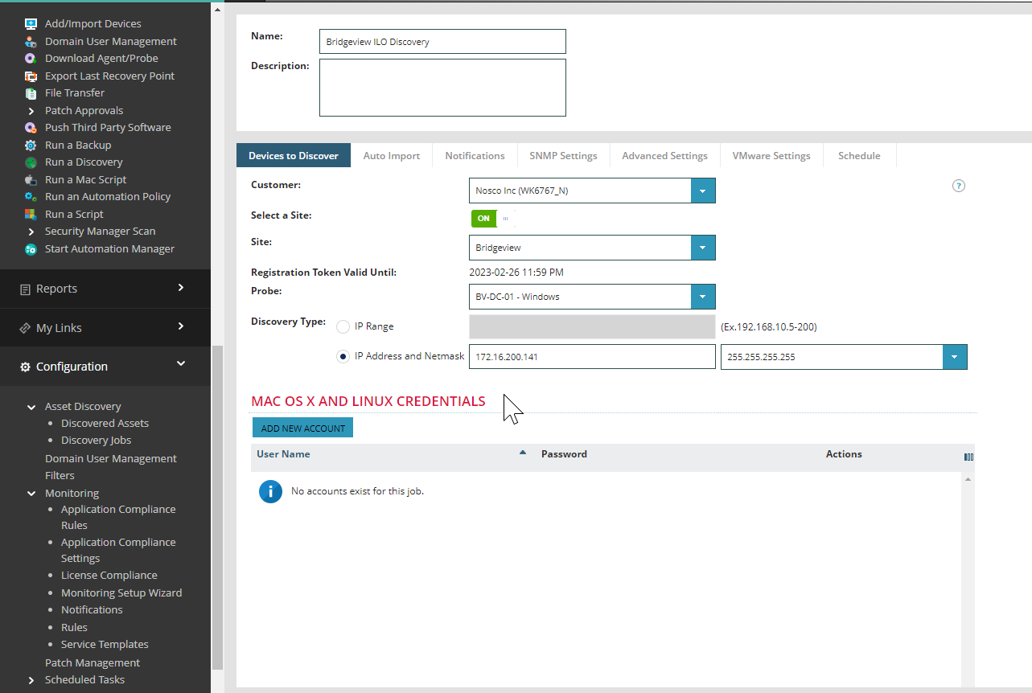
- Click on the SNMP Settings tab
- Click Add SNMP Credential and Select SNMP v1
- Set the SNMP V2C Profile Name to Impact
- Set the Community String to impact
- 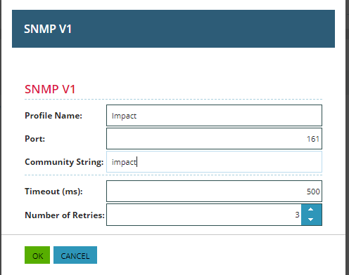

- Click Finish
- In INC go to Discovered Assets
- Locate the new devices. If the Device Class is Other perform the following
  - Select the ILO device(s)
  - Click Set Device Class/OS
  - 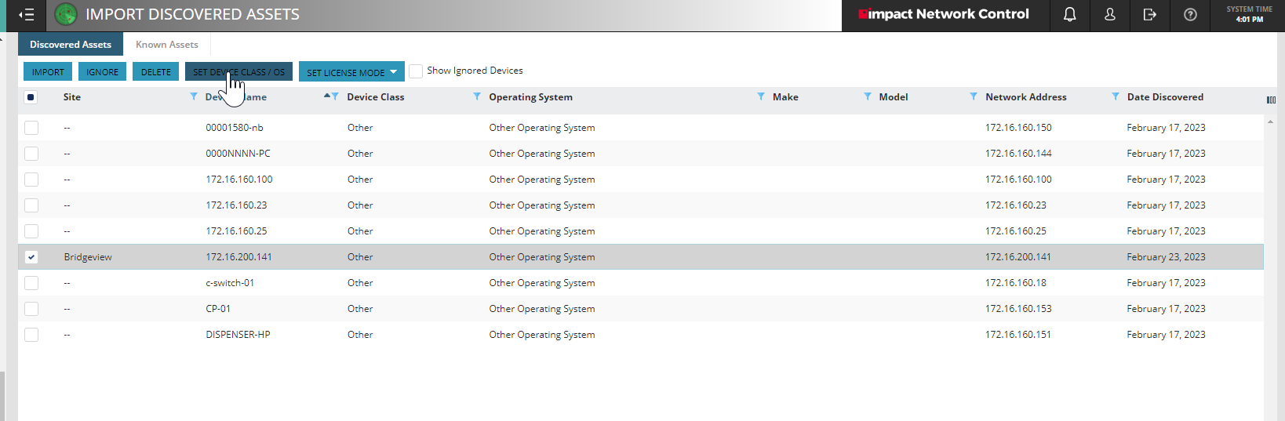
  - Change to Servers – Management Interface
  - Set the OS to Other Operating System
  - 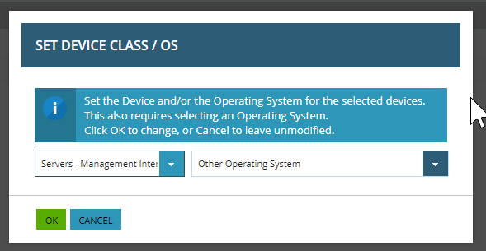
  - Click OK
- With the systems still highlighted, click Set License Mode
- 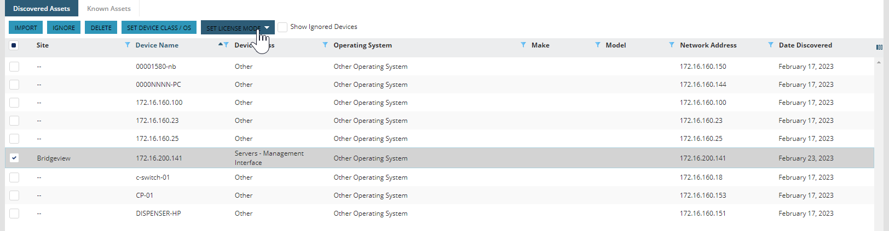
- Click Professional
- Click Import
- 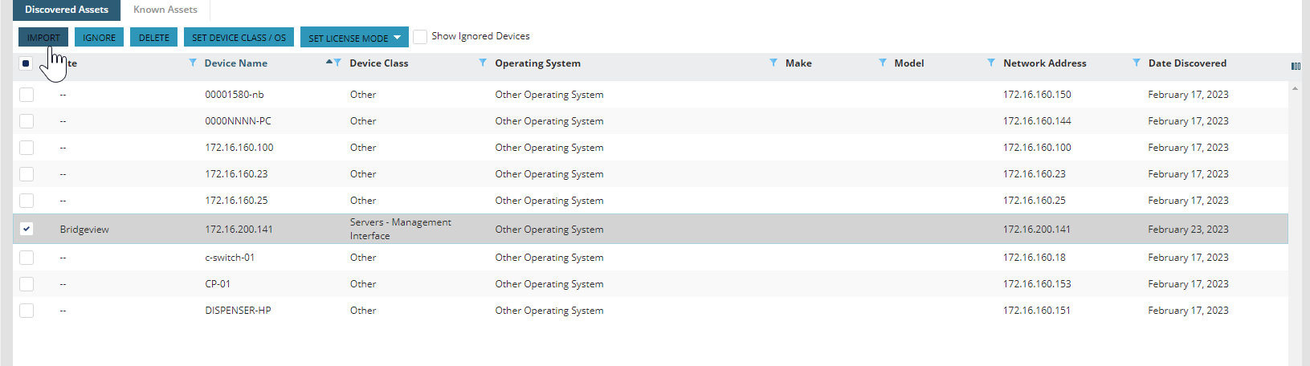
- Click on Views and All Devices
- Click on the device to enter the Details
- Click the Settings tab
- Click the Monitoring Options tab
- Place a check in Use SNMP:
- Set SNMP version to v2c
- Set Community String to impact
- Click Save
- 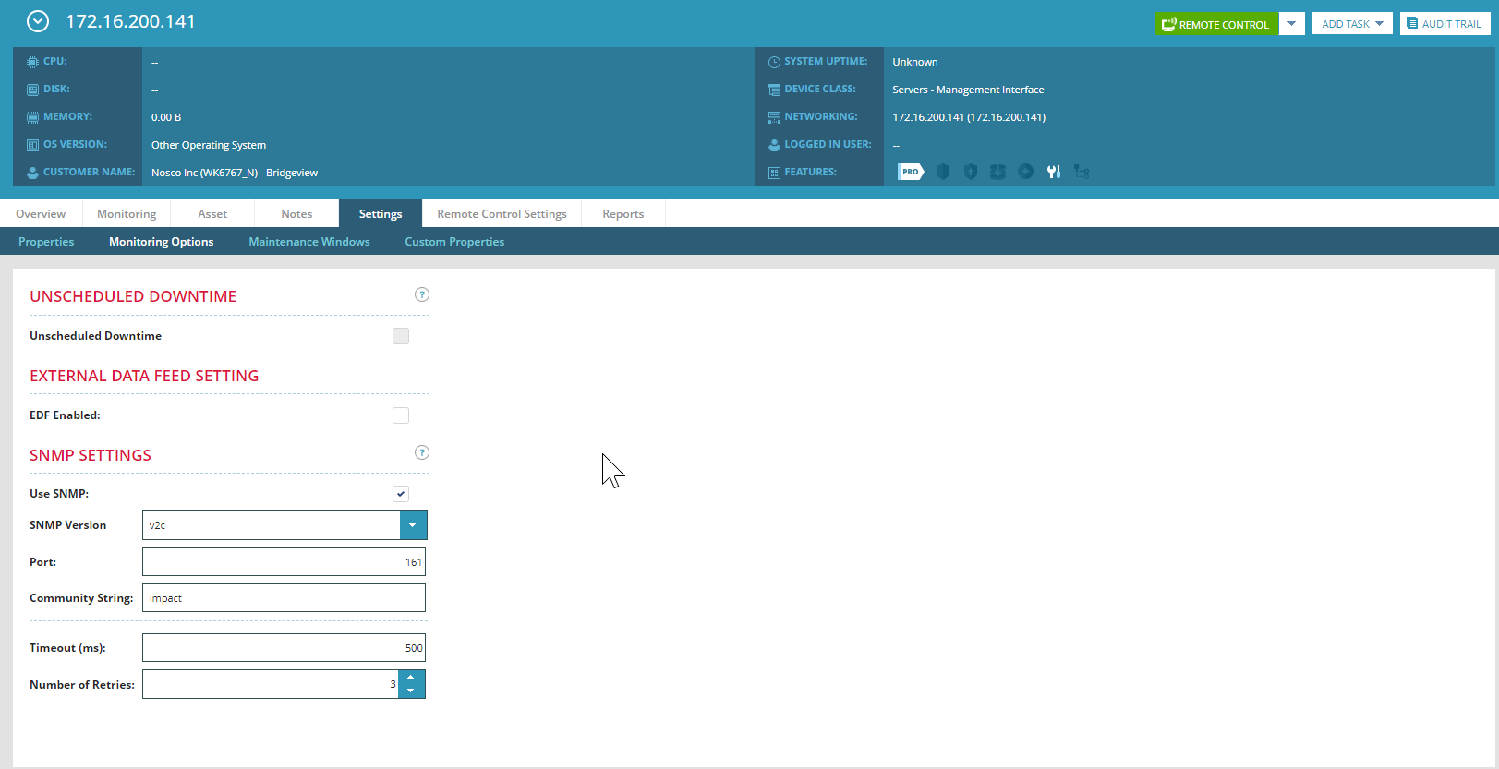
- Click Add
- Select the following:
  - Fan Status (HP) – Add 1
  - Physical Drive (HP) - Add 1 for each drive installed in the server
  - Power Supply (HP) - Add 1
  - RAID Status (HP) – Add 1
  - Server Temp (HP) - Add 1
- The Services will show in Monitoring. Services that had more than one added will be duplicated. For instance, if there are 2 Hard drives, then both will currently be listed as Physical Drive (HP) – 0.0
- The following will be for changing the second Physical Drive service to point to the second Drive
  - Click on the second Physical Drive (HP) – 0.0
  - Click the Service Details tab
  - 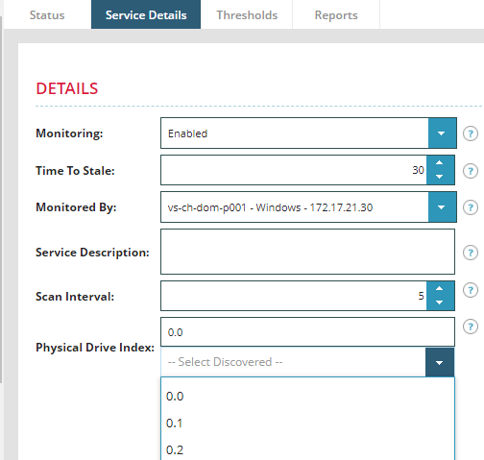
  - Under Physical Drive Index click the drop down for Select Discovered
  - Select 0.1
- Click OK
- The change should now be reflected in the monitoring section.
- 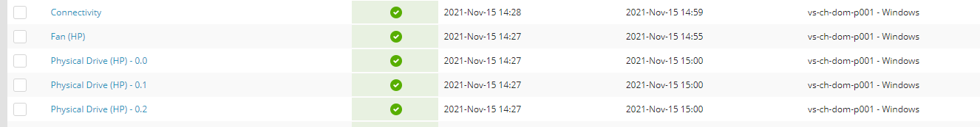
- Perform any changes on all remaining drives. Drive locations are shown in the screenshot below. The red arrows are the drive numbers. 1 needs to be subtracted from each drive to have it match what is responded to by SNMP.
- 